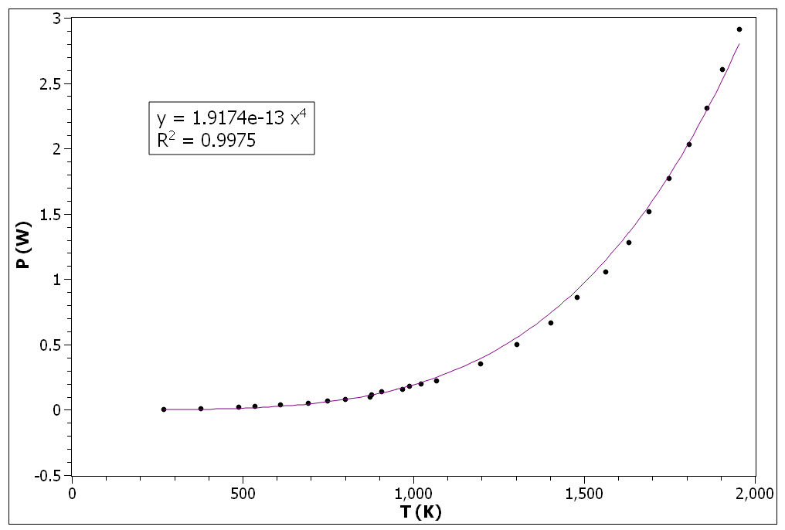

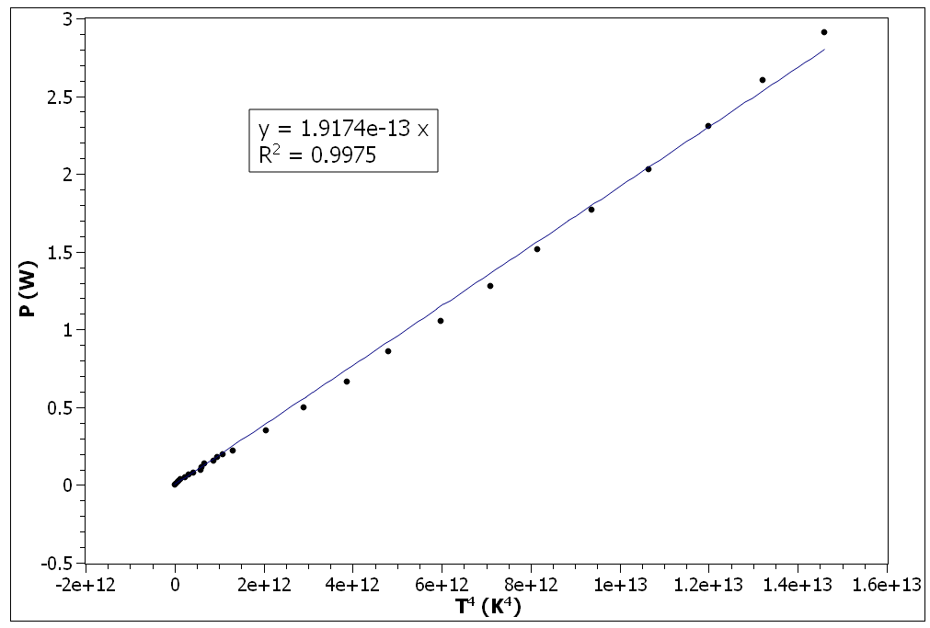

import numpy as np
from uncertainties import ufloat
from uncertainties import unumpy as unp
from scipy.optimize import curve_fit

file = np.loadtxt("Data.csv", delimiter = ",", skiprows=1, usecols=(0,1,4))

alpha = 5.21e-3
beta = 7.2e-7
TG = 800 # K

n = len(file)

Ta = [file[i,2] for i in range(n)]
V = [ufloat(file[i,0],0.1) for i in range(n)] # V
I = [ufloat(file[i,1],0.1) for i in range(n)] # mA

R = [(V[i]/I[i])*1000 for i in range(n)] # ohm
P = [(V[i]*I[i])/1000 for i in range(n)] # W

R0 = R[7] / (1 + (alpha*TG) + (beta*TG*TG))

T = [(-1*alpha + unp.sqrt(alpha**2 - (4 * beta * (1 - (R[i]/R0)))))/(2*beta) for i in range(n)]

T4 = [T[i]**4 for i in range(n)]

T4_Ta4 = [T4[i] - Ta[i]**4 for i in range(n)]

def linear(x, p):
return p * x

popt1, pcov1 = curve_fit(linear, [T4[i].n for i in range(n)], [P[i].n for i in range(n)])
popt2, pcov2 = curve_fit(linear, [T4_Ta4[i].n for i in range(n)], [P[i].n for i in range(n)])

# Error between slope of [P vs T^4] and [P vs (T^4-Ta^4)]
error = (popt2-popt1)/popt2 * 100

